**Professional Practice in IT**

**Ronan & Larry**

**Planning Phase**

**Introduction**

For our project, we have decided to create an app which will showcase our skills we feel to the best of our abilities. We plan to make an app which takes in scores from local level Junior match’s in Gaelic Football, as well as local underage match’s for example under 13s maybe to minor.

Here in this document we shall outline what we wish to project to be about, where we got the idea for the project, our planning of what we wish the app to look like, technical requirements for the project, software to be used, how to app itself is to be used and unique idea’s we feel will make our app stand out.

**Our App**

We feel that out app will be naturally a score keeping app but we want to keep it within the level of Galway. We plan to have a homepage with all the football teams in Galway a bit of history about each club when you click their emblem, as well as the latest scores from their match’s when you click into said club. There will be an Admin version of the app for referees, as they will be our people keeping track of the score, no more need to pen and paper, all they need is their phone to take down the score, then this will be stored on a backend database.

We also plan to make a QR code connected to each pitch a match is being played on, for example in Tuam play Salthill in Tuam stadium, there will be QR code signs around the pitch, so if you are unsure about the score of the match just click onto your phone and you will get the live score of the match.

**List of thoughts for functions of the app**

-QR scanner to provide score to anyone within the venue

-Online access to any match scores

-Brief history or description about each club

-Stadium/ pitch gps location provided (link to google maps)

-Admin version for use by refs or score keepers from either side playing

-Stat tracker for admin version (Turnovers/tackles won/lost…..etc)

Link to recording - https://galwaymayoinstitute.sharepoint.com/sites/Student-ProfessionalPracticeinITRonanLarry/Shared%20Documents/General/Recordings/View%20Only/PPIT%20Meeting-20220209_114341-Meeting%20Recording.mp4?web=1

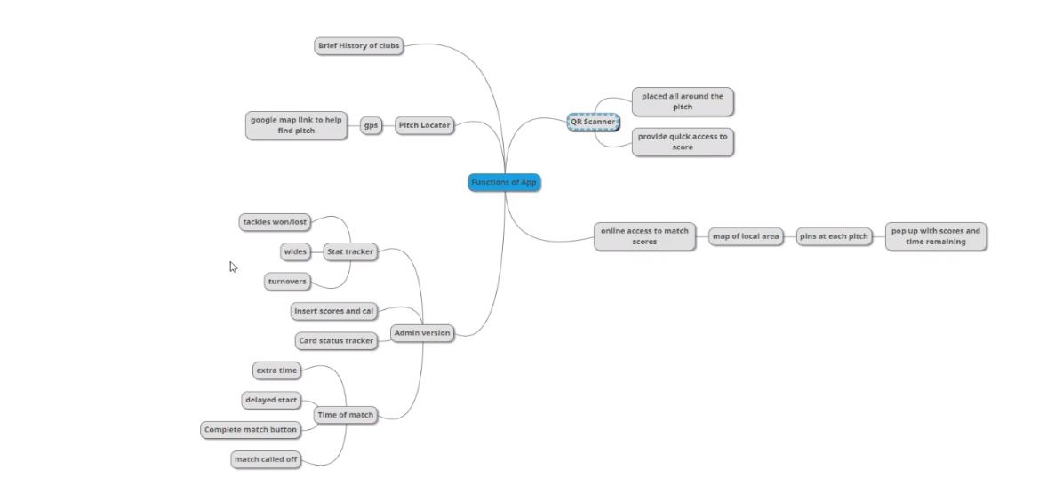

**Our Objectives**

1 – To hopefully attract greater attention to underage and junior Gaelic football match’s in Galway

2 – Helping parents while travelling to away match’s to find GAA pitch’s easier

3 – To advance GAA match’s so as everything isn’t written down anymore, it is also possible it would be easier to review a match we feel.

4 – Attract more interest for passer byes if they wish to see a match and get the score using the QR code.

5 – Help management track where they went wrong in a match e.g how many wides missed tackles etc.

6 – To aid in tracking scores of match’s which aren’t club senior and above, to give the attention Junior and underage deserve.

**Mock UI**

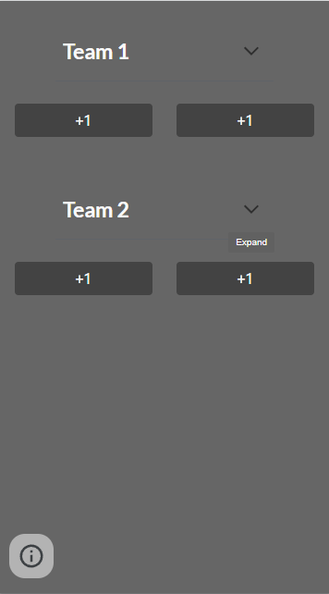

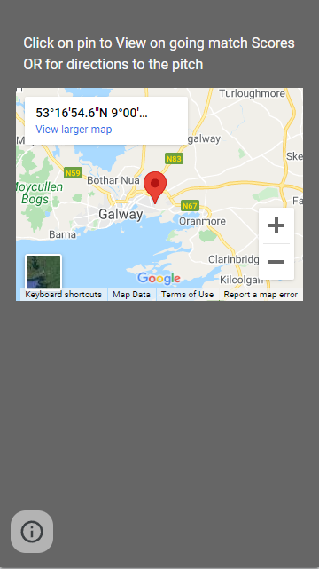

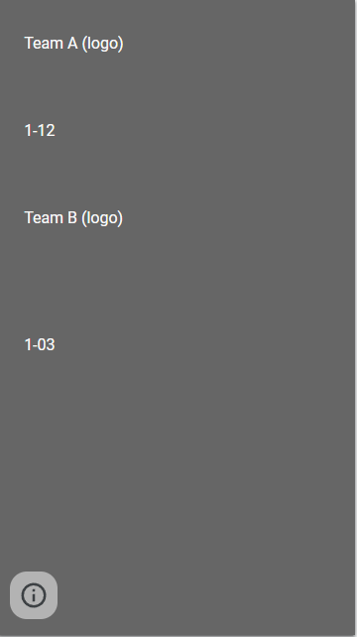

**List of features**

- login

-registration

- score tracker

-QR scanner system for live score updates

-map page with pins of all ongoing games

-ability to use the map feature to locate pitches

-Online access page with score updates of all on going or completed matches of the day

**Tech**

mongo db databaase (backend)

React(frontend)

**Wire frames**

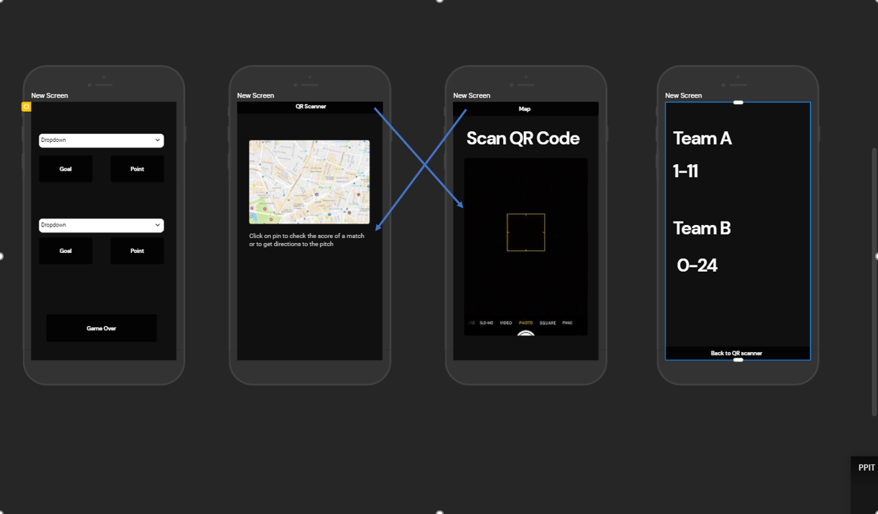

**Gantt Chart**

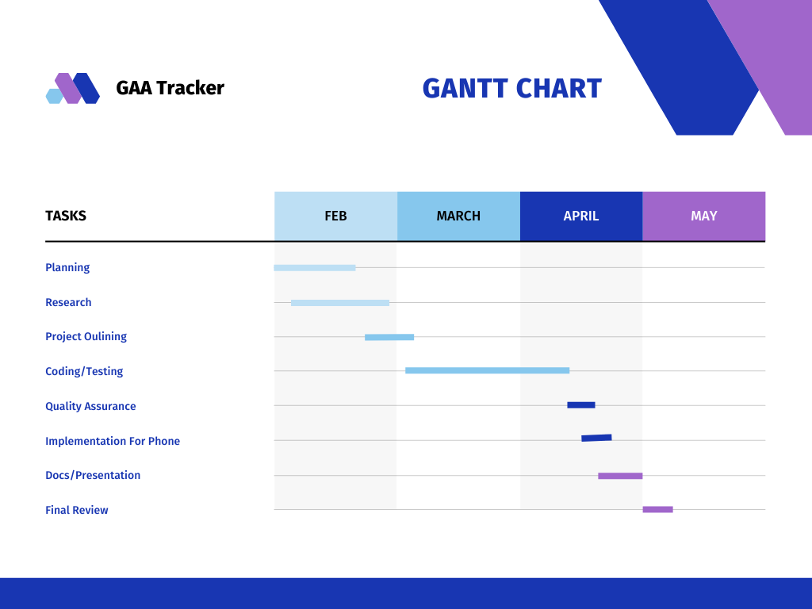

**Architecture Diagram**

